Islington Labour Party Public Meeting # Making Disabled People’s Rights a Reality ~ A Great Success
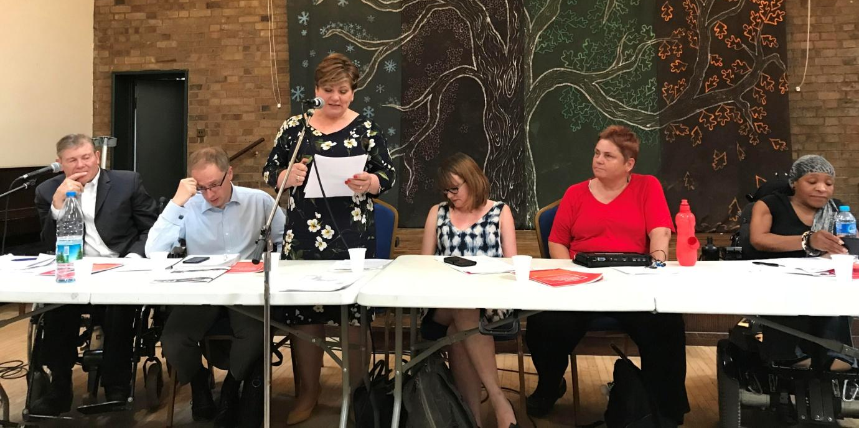
Speakers Left to Right. Richard Rieser-Islington North CLP Disability Officer, Richard Watts Leader of Islington Council, Emily Thornberry MP for Islington South, Ellen Clifford Inclusion London and DPAC, Kirsten Hearn, Labour Councillor Haringey and Michelle Daley Acting CEO Alliance for Inclusive Education.
The meeting attended by 35 disabled people and their allies put on record the appalling treatment of disabled people internationally, nationally and locally by the Conservative government. The more than £200m cuts that Islington Council has been forced by the Government to make loomed large with disabled service users making it clear that Islington’s potential closure of mental health centres will put more strain on hard stretched NHS services and cost more to the public purse. Cllr Watts replied saying “nothing was decided and the council wanted to engage in genuine consultation and was open to any innovative ideas, but was being forced to make reductions”.
Ellen Clifford of Inclusion London described how the Government had been held to account and found wanting on its treatment of disabled people by the United Nations. She explained both on a particular complaint in 2016 about the disproportionate impact of austerity measures on disabled people and the routine scrutiny of the UK Government's implementation of the UN Convention on the Rights of Persons with Disabilities the UN Committee had found the UK Government severely wanting and guilty of gross grave and systematic violations of human rights. Clifford went on to explain that this was not about comparing the UK to poorer countries, but as the 5th richest country in the world not allowing them to move backwards on implementation of disability rights.
Michelle Daley from Alliance for Inclusive Education made clear disabled children and students were being increasingly excluded and sent to segregated special schools, as mainstream schools and colleges were increasingly forced by Government to concentrate on the education of high achievers and ignore the needs of disabled students. Marketised Academies generally did not provide effectively for those with provide for those with SEND and resources for SEND were not keeping up with increasing demand. The answer was a complete overhaul of the system based on the principles of inclusive education.
Kirsten Hearn explained the issues of running to be a Councillor as a blind person and how her Local Labour Party had provided the extra support she needed. Now re-elected with a much increased majority she is now a Cabinet member on Haringey Council. She appealed to disabled people to get more involved in the Labour Party and seek office.
Emily Thornberry made clear that this and all the other issues disabled people were facing would be addressed by an incoming Labour Government which would be guided by discussions with Disabled People and their organisations. In 2017 Labour had been the only party to produce a Manifesto with and for Disabled People. Every day the callousness of the DWP in cutting benefits of disabled constituents was brought to her attention and they dealt with this successfully by case work, but the whole system needed changing to bring social justice to disabled people and this required a Labour Government.
Other areas made by participants included the need to support rail workers in their strikes for safe railways where disabled passengers could get the help they needed by keeping guards. Getting support provided to people with Autism by those with firsthand experience of the condition, not Age UK.
Disabled people make up 20% of the population at least with the Government saying there are 13 million who count as disabled under the equality act and they have a right to be free from discrimination and harassment. Disabled People Against the Cuts are campaigning for the implementation of Chapter 1 of the Equalities Act discrimination on grounds of social/economic circumstances which would lead to a future government redistributing income.
Richard Watts said that despite the massive cutbacks imposed on Islington the Council would continue to support disabled people. They are continuing to provide funding for free advice and advocacy through the Maximisation of Income Unit, CAB and Disability Rights and Disability Action in Islington leading to 90% success in PIP appeals. All new homes have to be built to lifetime homes accessibility standards, the Council continues to support Inclusive education in our schools.
In closing the meeting Richard Rieser Chairing said the legislation with the Equality Act was in place but it needed implementation and there was a need to challenge disability discrimination throughout Islington and the Labour Party needed to get better at including disabled people. He called on the Council to send information leaflets to every household on their disability rights and how to challenge PIP and ESA assessments and Universal Credit as it gets rolled out.
The Government were good at creating smokescreens about what they are doing to disabled people. They are hosting a Global Summit on Disability on 25th July at the Olympic Park while not acknowledging or recognising the UN damning report on their domestic policies. We need to keep organising as disabled people with our allies in the Labour Party and elsewhere to change the Government and introduce genuine disability equality in this country.

